1. ER Diagram (Crow’s Foot Notation)
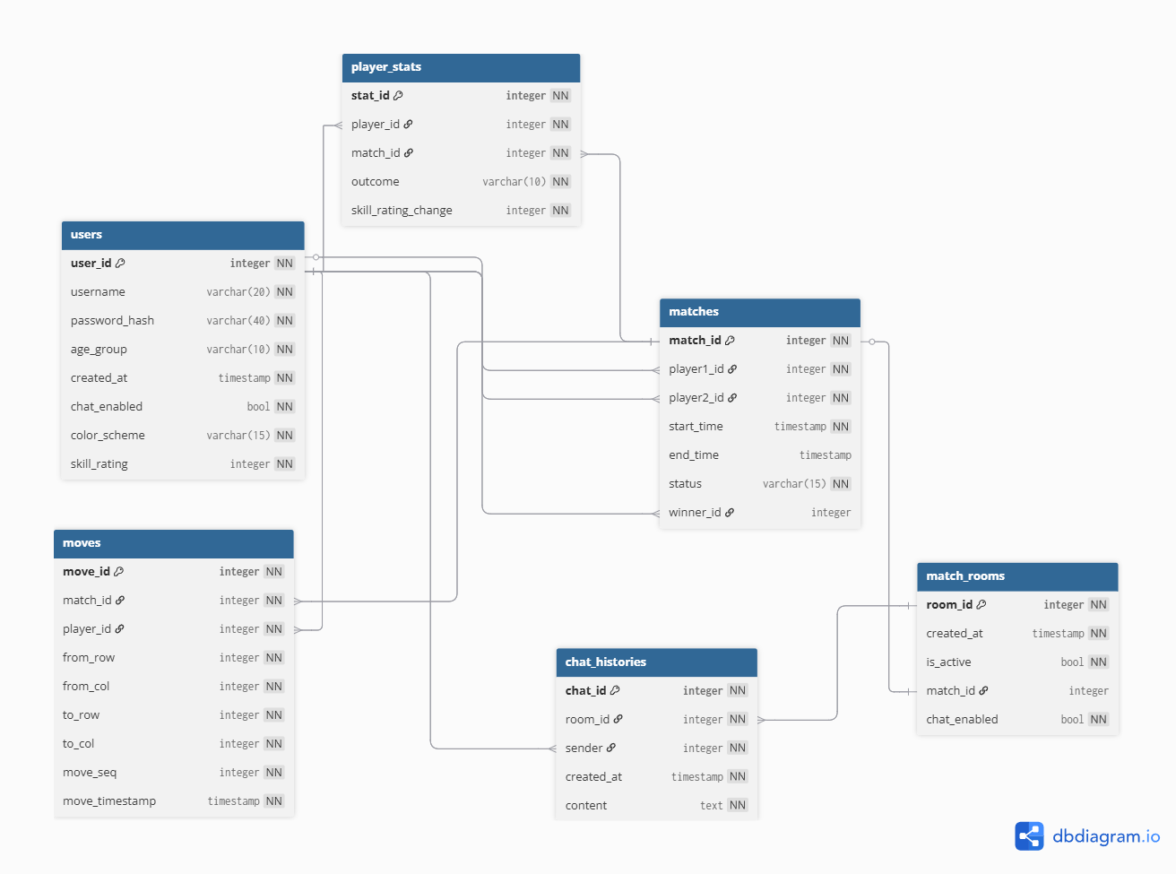
2. Data Dictionary
Table 1: users
Field Name | Data Type | Key Type | Nullable | Default | Description
user_id | INTEGER | PK | NOT NULL | - | Unique identifier for each user
username | VARCHAR (20) | - | NOT NULL | - | Player's username
password_hash | VARCHAR (40) | - | NOT NULL | - | MD5 hash of the user's password used for authentication
age_group | VARCHAR (10) | - | NOT NULL | - | Age group (child/adult)
created_at | TIMESTAMP | - | NOT NULL | - | Account creation time
chat_enabled | BOOL | - | NOT NULL | true | Whether chat is enabled
color_scheme | VARCHAR(15) | - | NOT NULL | default | UI color scheme  (default/colorblind)
skill_rating | INTEGER | - | NOT NULL | 0 | Skill rating used for matchmaking
Table 2: matches
Field Name | Data Type | Key Type | Nullable | Default | Description
match_id | INTEGER | PK | NOT NULL | - | Unique identifier for a match
player1_id | INTEGER | FK | NOT NULL | - | First player
player2_id | INTEGER | FK | NOT NULL | - | Second player
start_time | TIMESTAMP | - | NOT NULL | - | The starting time of the match
end_time | TIMESTAMP | - | NULL | - | The ending time of the match
status | VARCHAR(15) | - | NOT NULL | in_progress | Current status of the match  (in_progress/completed)
winner_id | INTEGER | FK | NULL | - | ID of the winning player
Table 3: moves
Field Name | Data Type | Key Type | Nullable | Default | Description
move_id | INTEGER | PK | NOT NULL | - | Unique identifier for a move
match_id | INTEGER | FK | NOT NULL | - | Match ID
player_id | INTEGER | FK | NOT NULL | - | Player ID
from_row | INTEGER | - | NOT NULL | - | The row number of the piece's starting position
from_col | INTEGER | - | NOT NULL | - | The column number of the piece's starting position
to_row | INTEGER | - | NOT NULL | - | The row number of the piece's destination position
to_col | INTEGER | - | NOT NULL | - | The column number of the piece's destination position
move_seq | INTEGER | - | NOT NULL | - | Order of moves in the match
move_timestamp | TIMESTAMP | - | NOT NULL | Current  timestamp | Timestamp of the move
Table 4: player_stats
Field Name | Data Type | Key Type | Nullable | Default | Description
stat_id | INTEGER | PK | NOT NULL | - | Unique identifier for the stats
player_id | INTEGER | FK | NOT NULL | - | Player ID
match_id | INTEGER | FK | NOT NULL | - | Match ID
outcome | VARCHAR(10) | - | NOT NULL | - | The outcome is win, loss, or draw.
skill_rating_change | INTEGER | - | NOT NULL | - | Change in skill rating
Table 5: match_rooms
Field Name | Data Type | Key Type | Nullable | Default | Description
room_id | INTEGER | PK | NOT NULL | - | Unique identifier for the stats
created_at | TIMESTAMP | - | NOT NULL | Current  timestamp | Match room creation time
is_active | BOOL | - | NOT NULL | false | Whether the match room is active
match_id | INTEGER | FK | NULL | - | Match ID
chat_enabled | BOOL | - | NOT NULL | true | Whether chat is enabled
Table 6: chat_histories
Field Name | Data Type | Key Type | Nullable | Default | Description
chat_id | INTEGER | PK | NOT NULL | - | Unique identifier for the chat message
room_id | INTEGER | FK | NOT NULL | - | Chat Room ID
sender | INTEGER | FK | NOT NULL | - | Message sender
created_at | TIMESTAMP | - | NOT NULL | Current  timestamp | Chat message creation time
content | TEXT | - | NOT NULL | - | Message content

